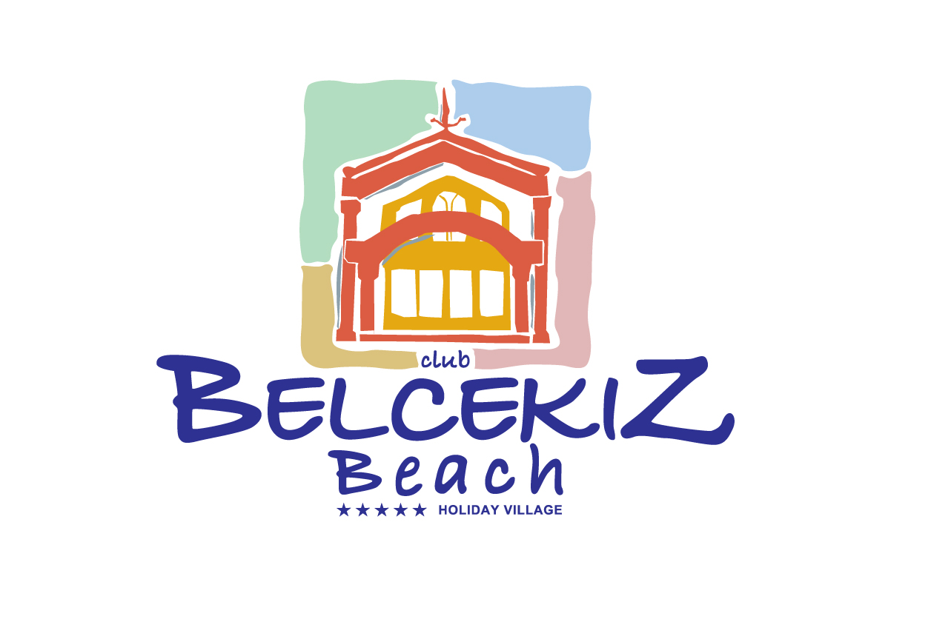
HOTEL INFOSHEET 2019

NAME OF THE HOTEL: CLUB BELCEKIZ BEACH
CATEGORY OF THE HOTEL (STAR) : 5 YILDIZ

Pension (Board) : | ALL INCLUSIVE
Foundation Date of the Hotel : | 1993
Last renovation date : | 2005
Area of the hotel ( m² ) : | 30 000 M2
Phone Number : | 0 252 617 00 77
Fax Number : | 0 252 617 03 72
Web Page : | www.belcekiz.com
Post Address : | BELCEKIZ BEACH CLUB ÖLÜDENİZ – FETHIYE –MUĞLA
Location of the hotel : | ÖLÜDENİZ
Distance to an airport : | 60 KM DALAMAN
Name and Distance of towns nearest to the hotel : | 13 KM FETHİYE

 | Name | E-mail
General Manager : | UFUK ÇELİK | ufuk@belcekiz.com
Sales Manager : | ULAS DENIZ | info@belcekiz.com
Front Office Manager : | ULAS DENIZ | info@belcekiz.com
Reservation Manager : | ULAS DENIZ | info@belcekiz.com
Accounting Manager : | FATİH DENİZ | fatihdeniz@belcekiz.com

BUILDINGS | How many buildings? | How many floors? |  | How many buildings? | How many floors?
Main Building | 3 | 2 | Anex Building | 3 | 2 - 3
Bungalow | - | - | Others | - | -
Villa | - | -

FOOD & BEVERAGES | How many | Capacity
Outdoor Restaurants (including a la carte rest.) | 2 | 100 / 300
Indoor Restaurants (including a la carte rest.) | 1 | 250
Bars | 5 | 200/200/100/50/50

CONFERENCE  HALL | Hall’s Name | Capacity  (theatre type)
HALL 1 | MEETING ROOM | 100
HALL 2 | TV ROOM | 100

 | NAME OF THE EQUIPMENT | EXTRA | FREE
CONFERENCE HALL’S EQUIPMENTS | WHITE BOARD |  | X
CONFERENCE HALL’S EQUIPMENTS | BARCOVISION |  | X
CONFERENCE HALL’S EQUIPMENTS | FLIPCHART |  | X

Size ( m2)
Outdoor Swimming Pool (Children pools are not included) |  | 1.: 810 M2 |  | 4.: |  | 7.:
 |  | 2.: 130 M2 |  | 5.: |  | 8.:
 |  | 3.: |  | 6.: |  | 9.:
Outdoor – Indoor Pool’s Working Hours: |  |  |  | 09:00 – 18:00
 | How many? | Court’s Ground
Tennis Courts | 1 | HARD FLOOR

 | YES | NO |  | EXTRA | FREE
Safe Box in the room | X |  |  | X
Safe Box at the reception | X |  |  |  | X
Beauty Center | X |  |  | X
Laundry Service | X |  |  | X
Internet Cafe | X |  |  | X
 | YES | NO
Postal Service | X
Pets Allowed |  | X
Elevator |  | X |  | Working Hours
Doctor (EXTRA) | X |  |  | 24 HOURS
Nurse |  | X
Room Service |  | X

 | YES | NO
TV Satellite | X
Russian Channel | X
Polish Channel | X
Direct Phone | X
Hair Dryer | X
Shower | X
Bathtub | X (ANEX ROOMS)
Shower Cabin | X
Balcony | X
Terrace | X
Baby Coat | X |  |  | Extra | Free
Mini bar (Full) | X |  |  |  | X
Internet Connection In the Room
Cable connection
Wireless X (PUBLIC AREA)
 | Carpet | Ceramic Tile | Other
Room Floor |  |  | PARQUET
 | Central | Split
Air Conditioning |  | X
Air Conditioning’s working hours | 24 HRS

BEACH
Hotel’s Beach:
Private Beach Public Beach X Private part on the Public beach
Length of the beach ____2000______ m
Beach (Sandy, Pebble, Sandy & Pebble , Platform) : SANDY & PEBBLE
Hotel is _____50__________ meters away from the beach
Road between hotel and beach No Car Road Walking Road X
Is there an underpass between hotel and the beach Yes No X
Shuttle Service to beach Yes X No X How many times a day : TO PRIVATE BEACHES
Shuttle Service to beach Free X Extra TO PRIVATE BEACHES

 | YES | NO | EXTRA | FREE
Umbrella | X |  | X
Chaise Longue | X |  | X
Mattress | X |  | X
Beach Towels | X |  |  | X

FOR CHILDREN
- Children’s Pool Yes X No Quantity : __1 / OUTDOOR__ (outdoor / indoor, please specify)
- Children’s Animation Yes X No
- Mini Club Yes X No
Working Hours 10:00 – 12:00 / 14:00 – 16:00
Children’s Age 04 - 12
- Baby Sitter Yes X No
Working Hours ON REQUEST
Rates (per hour ) NOT DECIDED
Is Baby Sitter a Professional one? Yes No X
- Baby carriage Yes X No Free Extra X
- Is there a children’s menu in restaurants ? Yes X No
Consists of : CHILDREN BUFFET
- Are there baby chairs in the restaurants ? Yes X No
- Is there a play ground? Yes X No

ANIMATION
Yes X No
Animation Languages : ENGLISH
Day Animation ( pool games , activities etc.) : Yes X No
Night Animation (shows, competitions ) : Yes X No

ACTIVITIES | FREE | EXTRA | NO
Fitness Center | X
Sauna |  | X
Turkish Bath |  | X
Massage |  | X
Table Tennis | X
Tennis Court | X
Lighting Of Tennis Court |  | X
Tennis Equipments |  | X
Basketball | X
Diving Club |  | X
Aerobics | X
Animation | X
Darts | X
Billiards | X
Horse Riding |  | X

CONCEPT OF THE HOTEL (BOARD)
ALL INCLUSIVE

 |  | HOURS | RESTAURANT’S NAME | OPEN BUFFET | FIXED MENU
Breakfast |  | 07:30 – 10:30 | MAIN REST. | X
Late Breakfast |  | 10:30 – 12:30 | SNACK BAR |  | X
Lunch |  | 12:30 – 14:00 | MAIN REST. | X
Snack Service |  | 14:00 – 17:00 | SNACK BAR |  | X
Ice Cream Service |  | 15:00 – 16:00 | SNACK BAR |  | X
Tea Time |  | 17:00 – 18:00 | SNACK BAR | X
Dinner |  | 19:00 – 21:00 | MAIN REST. | X
Night Meal |  | 23:00 – 24:00 | SNACK BAR |  | X
A'la Carte Restaurants
Name |  | Hours | With Reservation | Cuisine |  | Extra | Free
A’LA CARTE |  | 19:00 – 23:00 | YES | TAI –ITALIAN – INDIAN - FRANCE |  | X
TheHangOut |  | 12:00 – 00:00 | YES |  |  | X
 | Is there a limit for the usage of A’la Carte Restaurants ? If yes, please specify the details: MAX. 30 PAX

Bar Name |  | Hours |  |  | Self Service |  | Order | Drinks
PLAZA BAR |  | 18:00 – 01:00 |  |  |  |  | X | ALL LOCAL ALCOHOL AND SOFT DRINKS
POOL BAR |  | 09:00 – 24:00 |  |  |  |  | X | ALL LOCAL ALCOHOL AND SOFT DRINKS
POOL BAR 2 |  | 09:00 – 19:00 |  |  |  |  | X | LIMITED ALCOHOL AND SOFT DRINKS
LOBBY BAR |  | 08:00 – 18:00 |  |  |  |  | X | SOFT DRINKS
SNACK BAR |  | 14:00 – 17:00 |  |  |  |  | X | SOFT COLD DRINKS
The Concept is valid between the following hours: |  |  |  |  |  |  |  | 08:00 – 24:00
Local drinks which are included to the concept |  |  |  |  |  |  |  | ALL LOCAL DRINKS
Import drinks which are included to the concept: |  |  |  |  |  |  |  | NONE
Is Mini Bar included into to the concept? |  |  |  |  |  |  |  | YES
If yes, write down the content of Mini Bar? |  |  |  |  |  |  |  | WATER , MINERAL WATER, JUICE
How often is Mini Bar refilled? |  |  |  |  |  |  |  | ONLY ON ARRIVAL
Please specify the drinks /food which are not included into the concept: |  |  |  |  |  |  |  | TURKISH COFFEE, FRESH JUICE, ALL IMPORT DERINKS, COCTAILS

ROOM TYPES
ROOM TYPES AND NAMES HAVE TO COMPLY WITH THE PRICE LIST GIVEN IN THE CONTRACT

Total Number of Rooms | 218

THIS TABLE IS MADE FOR STANDARD ROOMS. PLEASE SPECIFY DETAILS SUCH AS SEA VIEW, LAND VIEW, GARDEN VIEW

ROOM TYPES |  | STANDART
(Name of the room)
Total number of rooms |  | 123 MAIN  95 ANEX
M2 |  | 22
How many rooms does it consist of ? |  | 1
Is there a door between rooms ? |  | NO
Is there a Balcony or Terrace or French Balcony ? |  | BALCONY OR TERRACE
How many Twin and/or French beds ? |  | MAIN 75 TWIN / 47 FRENCH  ANEX 53 TWIN / 42 FRENCH
Is there any sitting furniture? |  | ONLY 1 SOFA
Maximum Pax (Please specify if children have to share bed with their parents) |  | 2+1
Is it in the Main Building ? (If not, please specify the location ) |  | MAIN / ANEX
How many bathrooms ? |  | 1
Bathtub or Shower Cabin? |  | BATHTUB IN ANEX / SHOWER CABIN
How many WC’s (total)?
 | Yes |  | No | Total Number of Rooms |  | Room Type
DISABLED ROOM | X |  |  | 2 |  | STD , TWIN
NON SMOKING ROOM |  |  | X

Club BELCEKIZ BEACH
48300 Ölüdeniz – Fethiye
Tel : +90 252 617 00 77 – 617 02 32 Fax : +90 252 617 03 72
Web : www.belcekiz.com e-mail : info@belcekiz.com

