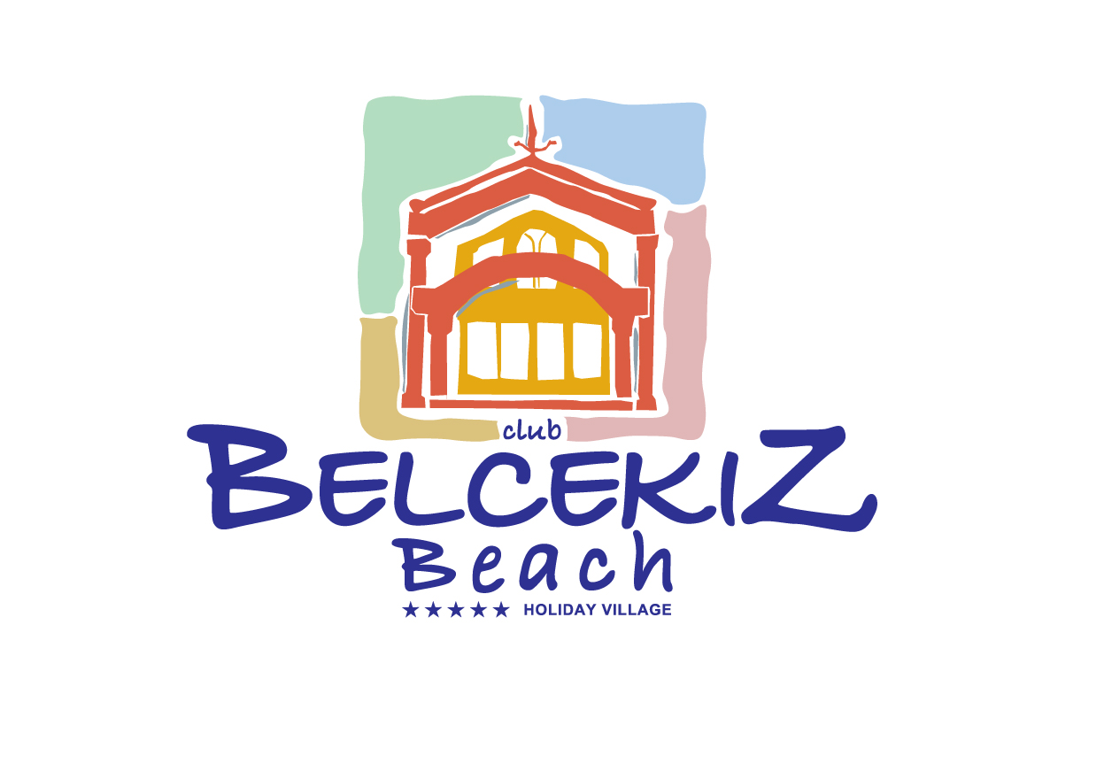

ALL INCLUSIVE FACILITIES TIMES

07:30-10:30 BREAKFAST MAIN RESTAURANT

10:30-12:30 LATE BREAKFAST SNACK BAR

14:00-17:00 SNACK SERVICE SNACK BAR

12:30-14:00 LUNCH MAIN RESTAURANT

15:00-16:00 ICE CREAM SERVICE SNACK BAR

17:00-18:00 TEA BREAK SNACK BAR

19:00-21:00 DINNER MAIN RESTAURANT

23:00-24:00 NIGHT SNACK SNACK BAR

- ALL INCLUSIVE TIMES BETWEEN 08:00-24:00

- LOCAL DRINKS ARE INCLUDED

- MINIBAR STOCKED ONLY ONCE WITH JUICE, SODA, WATER AS OF THE FIRST DAY OF ARRIVAL.

- TEA – COFFEE MAKING FACILITIES IN THE ROOM

- LAUNDRY, TELEPHONE, SAFE BOX IN THE ROOM, IMPORTED DRINKS, TURKISH BATH, SAUNA, MASSAGE, FLOODLIGHT FOR TENNIS COURT AND EQUIPMENTS ARE WITH CHARGE.

- AIR CONDITIONING CAN ONLY WORK EFFECTIVELY IF DOORS AND WINDOWS ARE KEPT SHUT.

- MONEY EXCHANGE: YOUR NEAREST MONEY EXCHANGE IS IN THE RECEPTION.

- ROOM KEYCARDS :PLEASE RETURN KEYCARDS WHİLE CHECKİNG OUT. UNRETURNED OR LOST KEYCARDS ARE SUBJECT TO A CHARCE OF 5£ GBP OR 6 € EURO

- BEACH TOWELS: YOU HAVE A TOWEL CARD WHICH WILL BE GIVEN TO YOU BY A RECEPTIONIST AT CHECK-IN, YOU CAN TAKE YOUR BEACH TOWELS WITH THAT CARD FROM turkısh bath. YOU MAY CHANGE YOUR DIRTY TOWEL BETWEEN 17.00-20.00 AT THE END OF YOUR HOLIDAY PLEASE RETURN YOUR TOWEL CARD BACK TO RECEPTION ON YOUR DEPARTURE DAY. FOR MISSING TOWELS YOU WILL BE CHARGED THE FEE OF (5 GBP) - (6 EURO) - (7USD) - (25 TL)
- ALA CARTE RESTAURANT: RESERVATION REQUIRED (9GBP) - (10 Euro) – (12usd)
- ınternet: to get ınternet access please put ın your passport & room number.
(HOTEL MANAGEMENT IS NOT RESPONSIBLE FOR GUEST’S BELONGINGS LOSS, IF THE GUEST DOESN’T LEAVE THEM IN THE SAFE BOX.)
Please refrain from lying in the bed after using carrot oil as this causes a problem with staining the bed sheets. If stains occur from the use of carrot oil we will have no choice but to charge it to you.
We would like to thank you for your cooperation.
HAVE A NICE HOLIDAY

CLUB BELCEKIZ BEACH HOLIDAY VILLAGE,

https://facebook/BelcekizBeachClub


https://instagram.com/BelcekizBeachClub


https://twitter.com/BelcekizBeach

